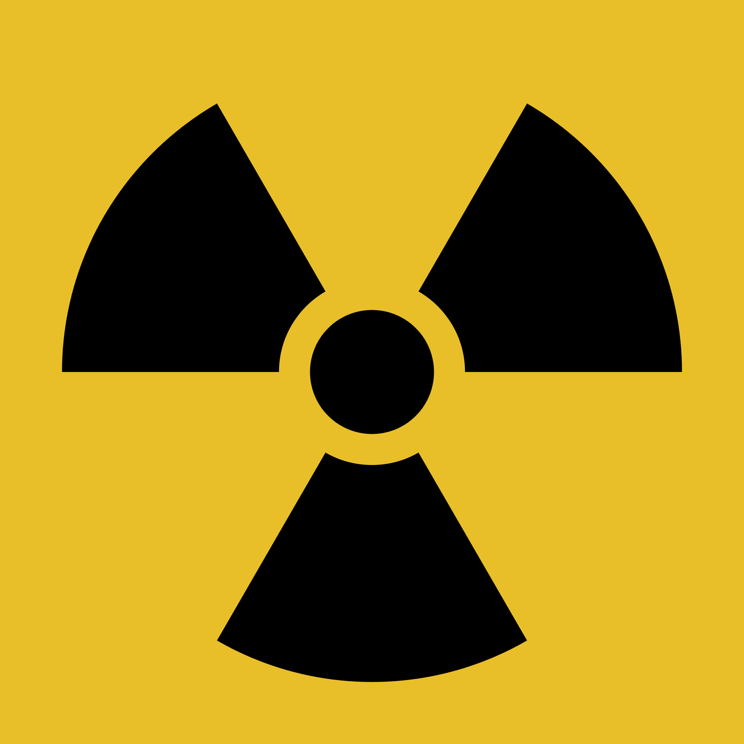

***UNITED STATES OFFICE OF RADIATION MANAGEMENT***

Welcome, innovators! You’ve been selected to participate in an exclusive project that will challenge you to think like a biomedical engineer and medical physicist. Every year, thousands of patients depend on radiation therapy for survival, but they face serious challenges, such as the risk of damaging healthy tissue and the heavy, cumbersome shields used to protect non-targeted areas.

Your mission, should you choose to accept it, is to **design a prototype that will revolutionize radiation therapy**—making it **safer, more effective, and accessible** to those who need it most. In this four-week challenge, you will work in small teams to **research**, **design**, and **develop a prototype** that could make a difference in how patients receive treatment for cancer.

### **Your Challenge:**

Radiation therapy is powerful, but current technologies often come with drawbacks. Imagine if you could solve these challenges: What if you could design a lightweight shield to protect delicate organs? What if you could improve the accuracy of radiation beams so that only cancer cells were targeted?

You and your team are **tasked with designing a new prototype that solves a real-world problem** in radiation therapy, focusing on one of the following cancer types:

* **Brain Cancer**
* **Lung Cancer**
* **Skin Cancer**

You will research how radiation works, investigate current technologies, and innovate by developing a prototype that improves upon existing methods. Your prototype can focus on any part of the process—improving shielding, enhancing precision, reducing weight, or any other innovation that solves a key problem.

Cancer treatment can be life-changing—and you have a chance to **improve it**. Your work will be presented as part of our **Innovation Showcase**, where your ideas will be reviewed by peers, educators, and perhaps even a guest from the medical field.

Think of your project as part of a real-world effort to make a difference in patient care. This is not just about a grade; this is about **imagining how science and innovation can change lives**.